https://ar.news.assyrianchurch.org/archives/81199?fbclid=IwAR2xY62uCjDbxhenMwb12_meS6X40sFLZARrucwR9LMpVkllRvxdNGpI064

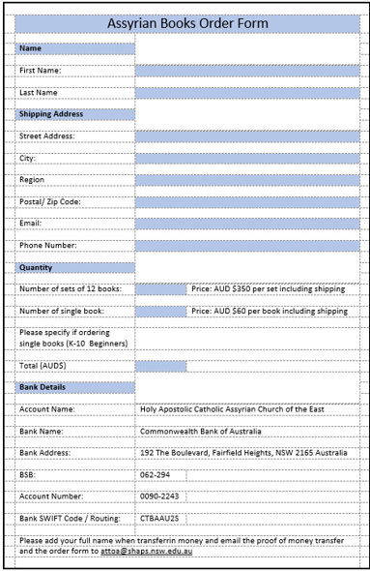
 | Assyrian Books Order Form
 | Name
 | First Name:
 | Last Name
 | Shipping Address
 | Street Address:
 | City:
 | Region
 | Postal/ Zip Code:
 | Email:
 | Phone Number:
 | Quantity
 | Number of sets of 12 books: |  | Price: AUD $350 per set including shipping
 | Number of single book: |  | Price: AUD $60 per book including shipping
 | Please specify if ordering single books (K-10 Beginners)
 | Total (AUD$)
 | Bank Details
 | Account Name: | Holy Apostolic Catholic Assyrian Church of the East
 | Bank Name: | Commonwealth Bank of Australia
 | Bank Address: | 192 The Boulevard, Fairfield Heights, NSW 2165 Australia
 | BSB: | 062-294
 | Account Number: | 0090-2243
 | Bank SWIFT Code / Routing: | CTBAAU2S
 | Please add your full name when transferrin money and email the proof of money transfer
 | and the order form to attoa@shaps.nsw.edu.au

